Kyushu Institute of Technology

Department of Applied Science for Integrated System Engineering

C:\Users\Owner\Pictures\symbol_4.gif

**BIRDS-3 Project**

**Antenna Deployment Test**

Laboratory of Spacecraft Environment Interaction Engineering



|  |  |  |  |
| --- | --- | --- | --- |
| **Date** | **Revision Number** | **Writer** | **Annotations** |
| 2019/01/08 | A | Kishimoto | Initial release |
|  |  |  |  |
|  |  |  |  |

**Contents**

[**1. Purpose** 3](#_Toc535004696)

[**2. Applicable Documents** 3](#_Toc535004697)

[**3. Test Article and method** 3](#_Toc535004698)

[**4. Proof test and Result** 5](#_Toc535004699)

[**5. Conclusion** 8](#_Toc535004700)

# **1. Purpose**

This document proves that BIRDS-3 satellites’ antennas will be deployed after 30 min and CW beacon (437.375MHz) will be transmitted from satellites after deployment antennas. This report carries out evaluation of three satellites(NepaliSat-1, Raavana-1 and Uguisu).

# **2.** **Applicable Documents**

* 1. JX-ESPC-101132C　“JEM Payload Accommodation Handbook Vol.8 Small Satellite Deployment Interface Control Document”

# **3. Test Article and method**

BIRDS-3 satellites are programed like Figure 3.1. It shows our satellites will move after deployment satellites from J-SSOD.

|  |
| --- |
| **Figure 3.1 Flow chart of BIRDS-3 after deployment from J-SSOD** |

Before starting test, one RBF pin should be removed from all three satellites and setup ground station (GS) equipment (turn on software and ICOM radio). First turn on video, timer and software of GS PC (screen recording and timer), then remove the second RBF pin from all three satellites. Antenna should be deployed after 30 min from removing both RBF pins.

**Table 3.1 Test tool**

|  |  |  |
| --- | --- | --- |
| No | Name | Quantity |
| 1 | Raavana-1(FM) | 1 |
| 2 | NepaliSat-1(FM) | 1 |
| 3 | Uguisu(FM) | 1 |
| 4 | Timer | 1 |
| 5 | Video | 1 |
| 6 | GS PC | 1 |
| 7 | ICOM Radio | 1 |

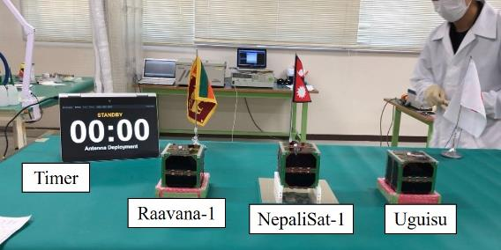

**Figure 3.2 Appearance of setup**

# **4. Proof test and Result**

Figure 4.1 shows the time when the satellites turned on. Figure 4.2 show after 30 min. Then Figure 4.3(a) and Figure 4.3(b) show the time when antennas deployed.

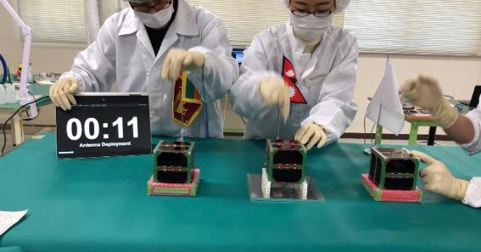

**Figure 4.1 Turning on satellite (the second RBF pin removed)**

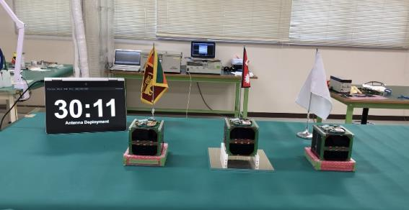

**Figure 4.2 30 min later after turning on satellites**



**Figure 4.3 Antenna deploy (a) Raavana-1 and Uguisu Deployed (after 30 min 12 sec) ,**

**(b) NepaliSat-1 Deployed (after 30 min 23 sec)**

After 30min 5sec, received Raavana-1’s CW beacon (437.375MHz) at GS PC (Figure 4.4). After 30min 40 sec, received NepaliSat-1’s CW beacon (437.375MHz) (Figure 4.5)and after 31 min 15 sec, received Uguisu’s CW beacon (437.375MHz) (Figure 4.6).

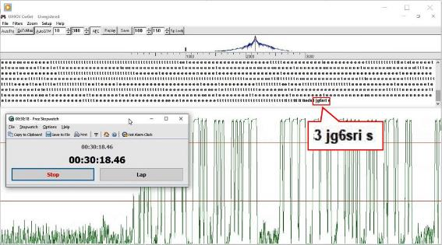

**Figure 4.4 Receiving CW from Raavana-1 (sri: Sri Lanka)**

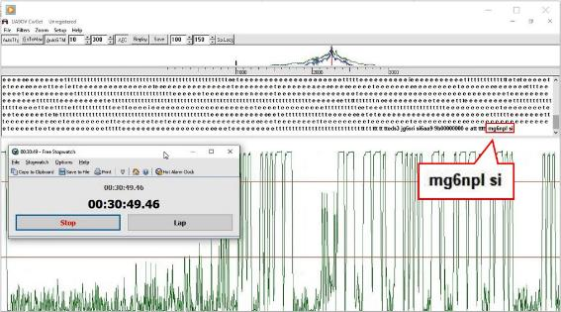

**Figure 4.5 Receiving CW from NepaliSat-1 (npl: Nepal)**

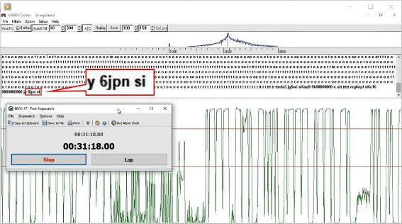

**Figure 4.6 Receiving CW from Uguisu (jpn: Japan)**

# **5. Conclusion**

BIRDS-3 antennas were deployed, and RF signal were also transmitted after 30 min releasing all inhibit switch. RF frequency was 437.375MHz. The requirements to release from ISS was confirmed.